Exercises Propositional RESOLUTION
Exercise 1
Using general resolution prove that the following formulas are theorems.
- ;

Exercise 2
Using the set-of-support strategy prove the following deductions:
 | - 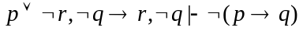
- 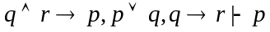 | - 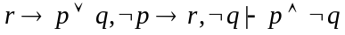
- 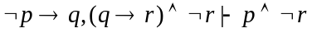
 | - 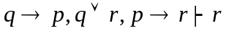

Exercise 3
Consider the following hypotheses:
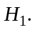 Mary will go to London this summer if both her friends Kate and Susan go.
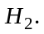 If Kate passes the English exam in May then she will go to London.
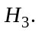 Kate was in hospital from April until July and she didn’t take the English exam.
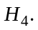This summer Susan will go to London on a business trip.
and the conclusion:
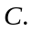 Will Mary go to London this summer?
Using resolution proof method check whether the following deduction holds: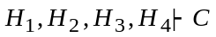.
Try to simplify the initial set of clauses by applying the transformations based on Davis-Putman procedure.

Exercise 4. Party
Hypotheses:
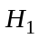. Mary will go to the party if Lucy will go and George will not go.
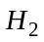. If John will go to the party then Lucy will go too.
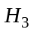. If John is in town he will go to the party.
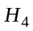. George is sick and can’t go to the party.
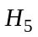. Yesterday John has returned in town from Paris.
Conclusion:
: Will Mary go to the party?
Using resolution proof method check whether the following deduction holds: 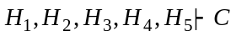.
Exercise 5
Using lock resolution prove the inconsistency of the following sets of clauses.
Choose two different indexings for the literals:
- ;
- ;
- ;
- ;
- ;
- ;
- ;
- .

Exercise 6
Check the consistency of the following sets of clauses using lock resolution..
- ;
- ;
- ;
- ;
- ;
- ;
- ;
- .

Exercise 7
Build a linear refutation from the following set of clauses:
- 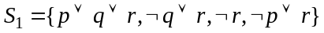;
- ;
- 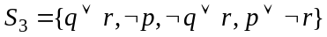;
- ;
- ;
- ;
- ;
- .

Exercise 8
Prove the consistency of the following sets of clauses using linear resolution.
- 
 



